**EXHIBIT A**

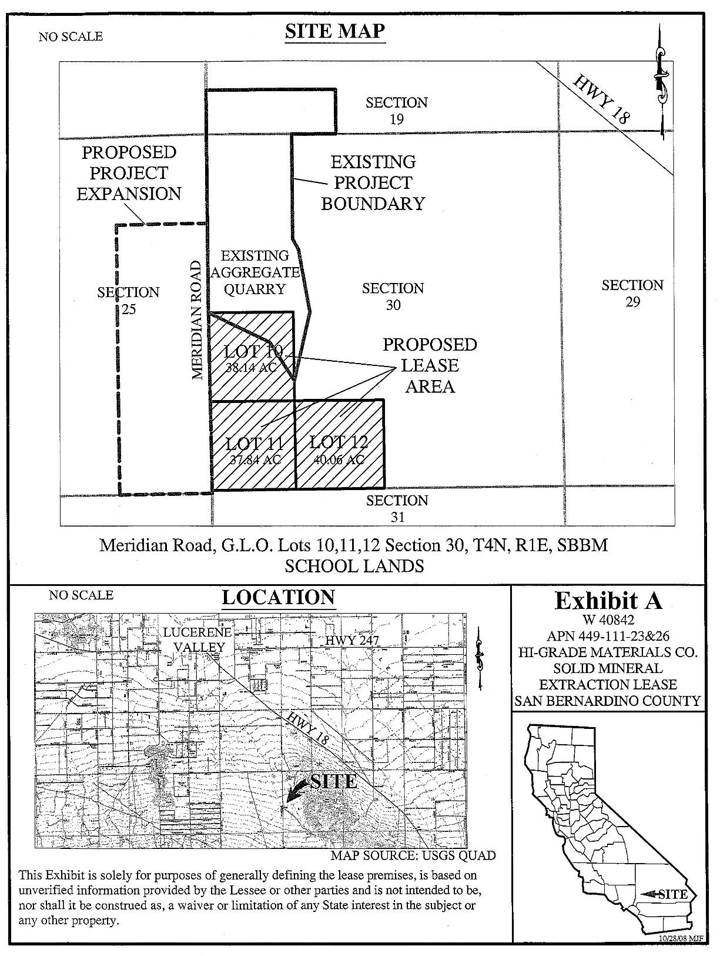W 40842