EXHIBIT A

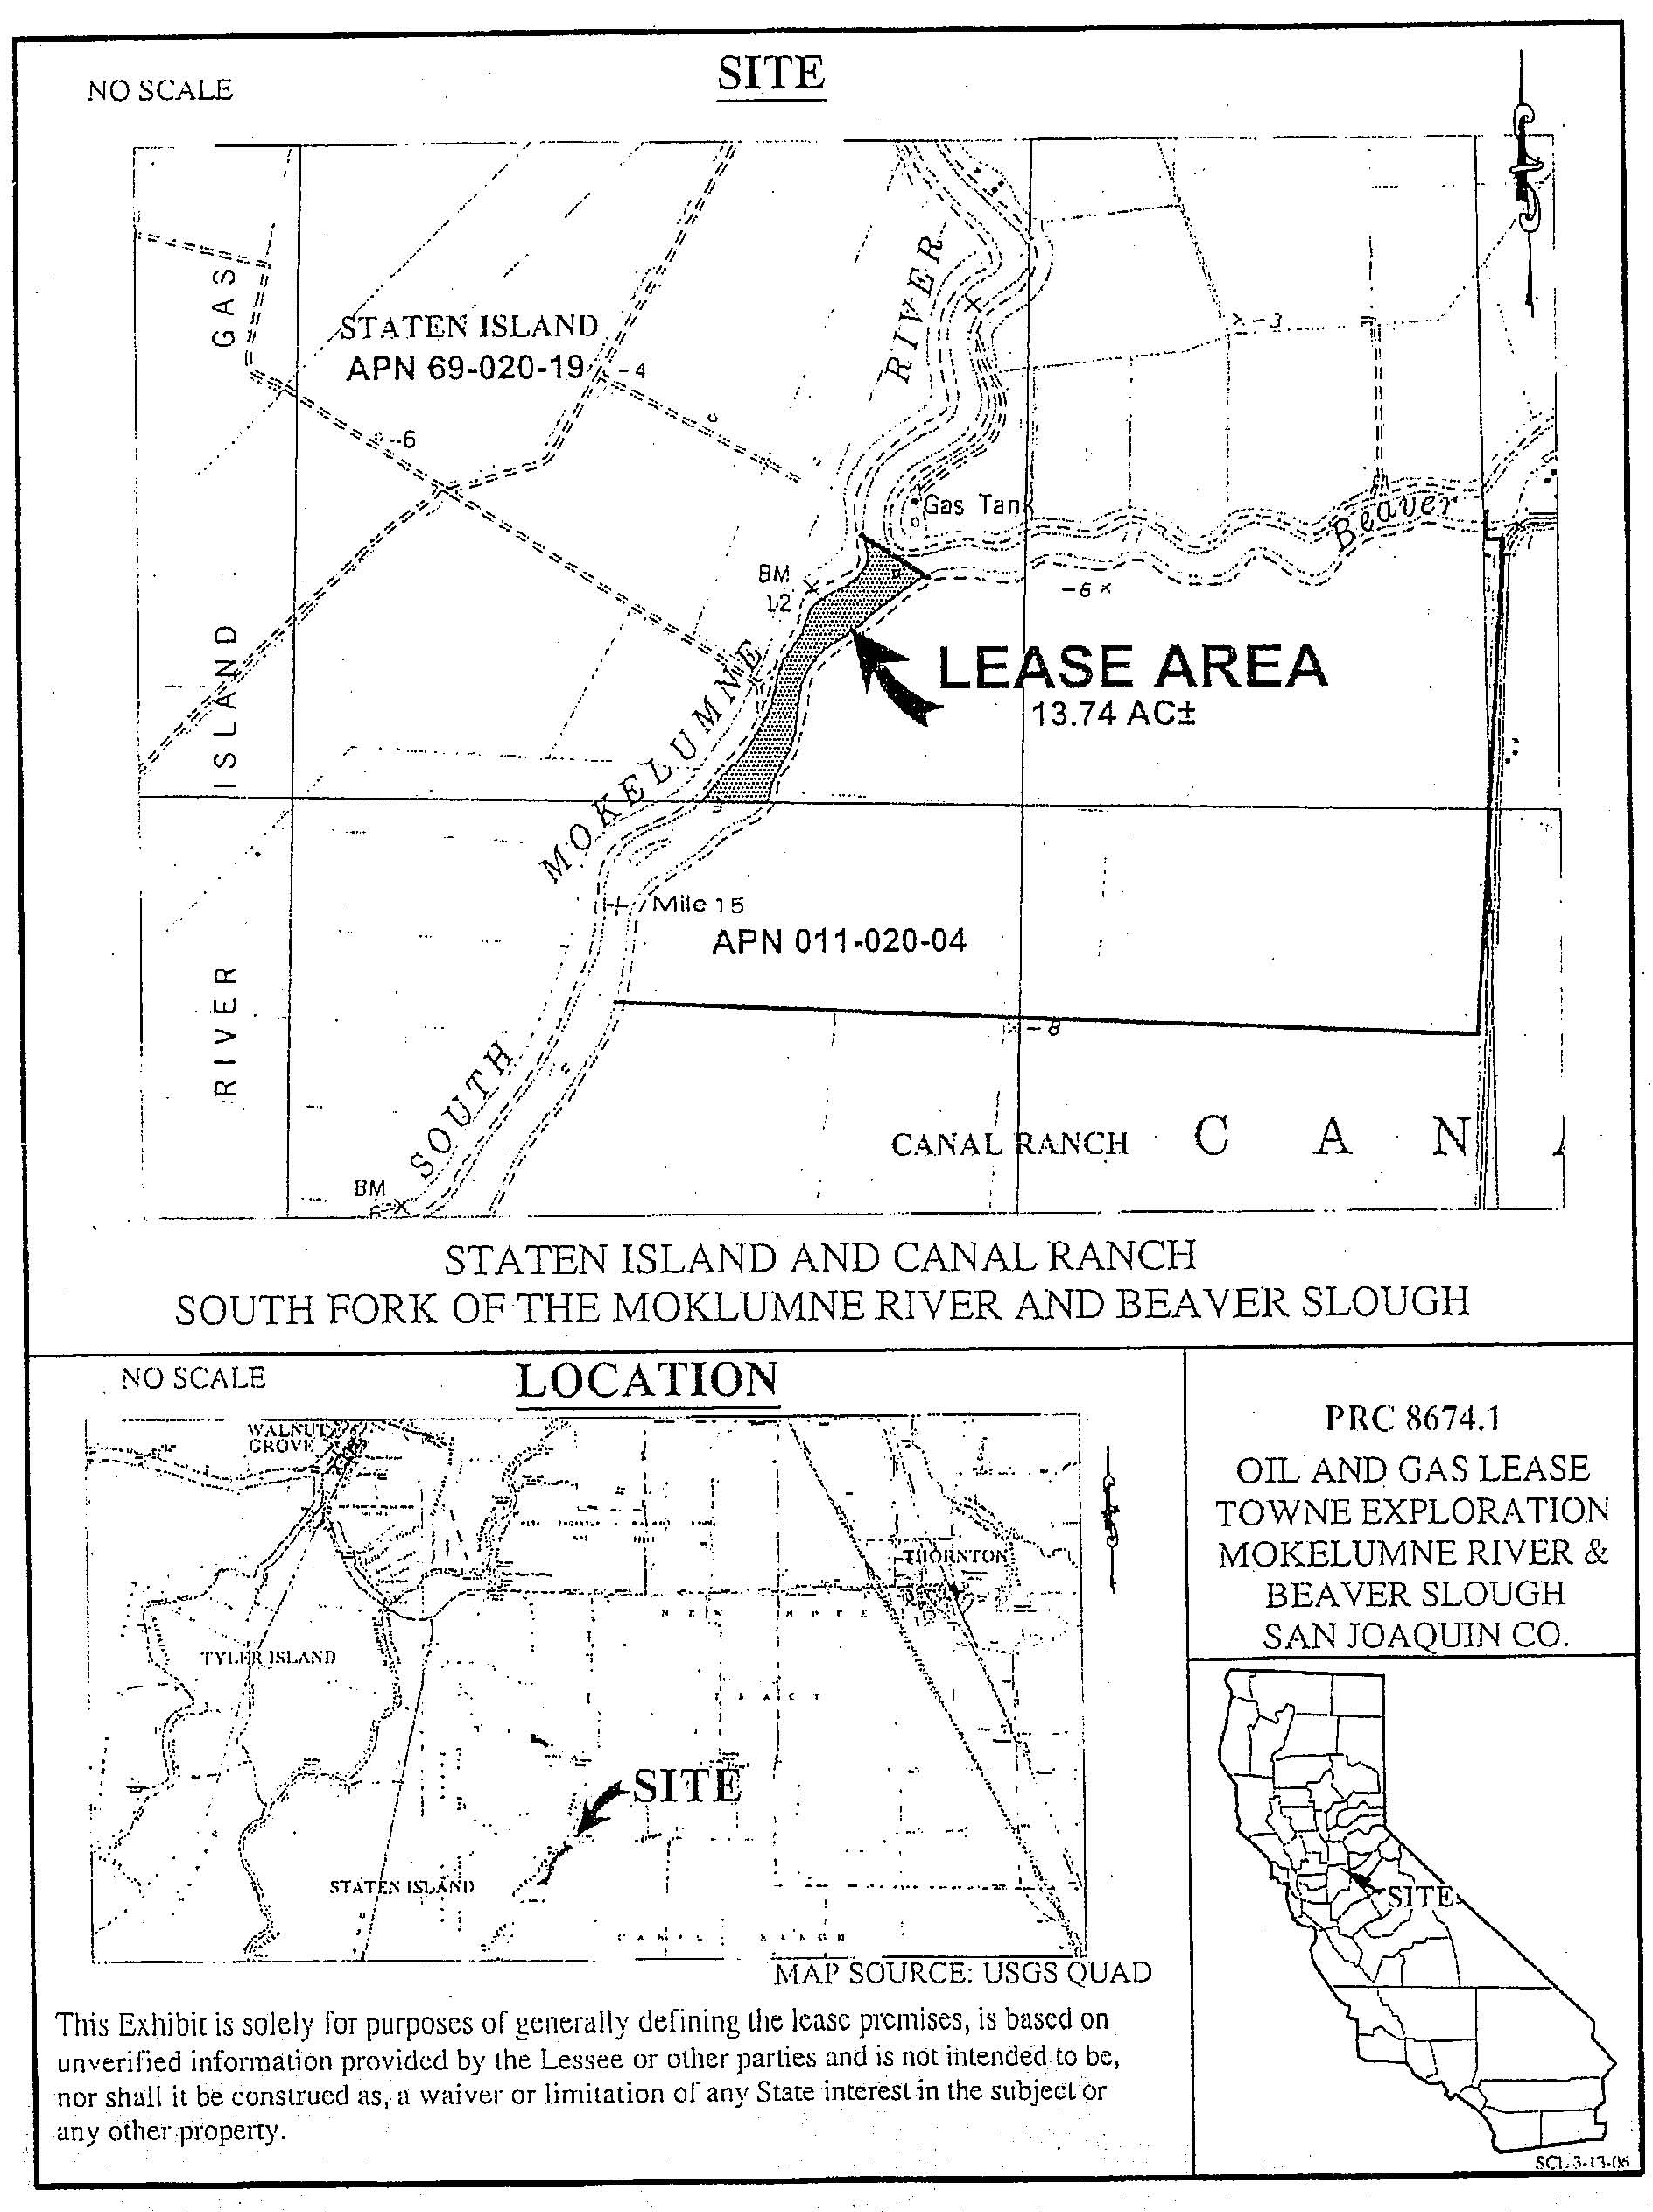
PRC 8674.1

