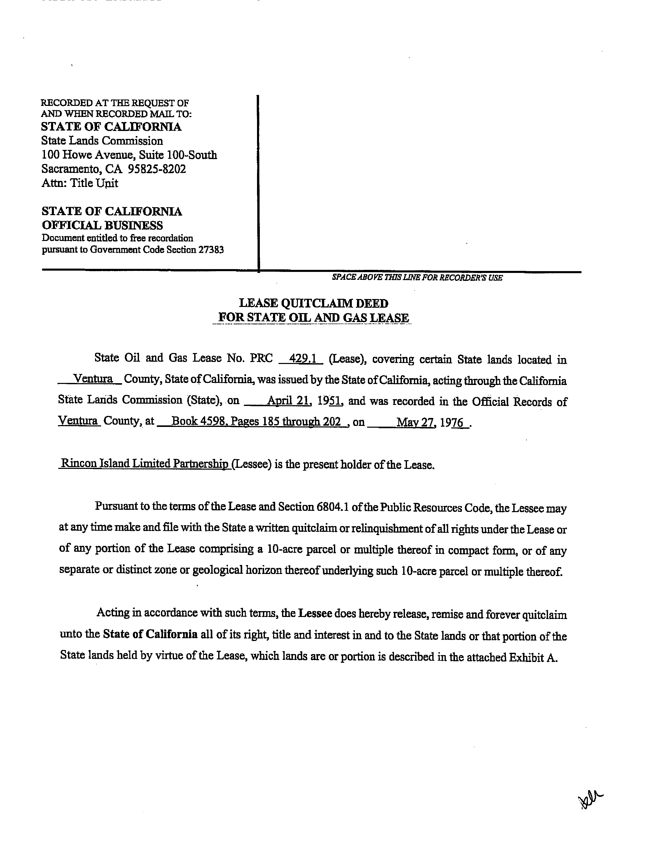

PRC 429.1

PRC 427.1

PRC 3125.1

W 30103

W 40896

**Exhibit C**

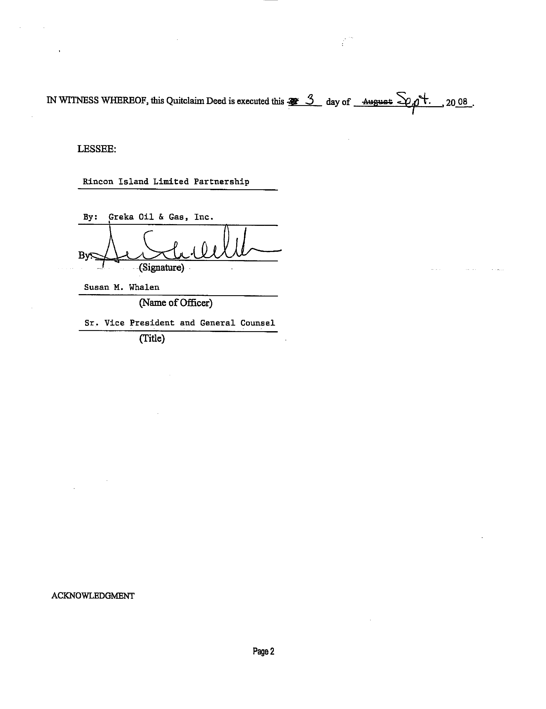v

