DO 5/2008

**SITE**

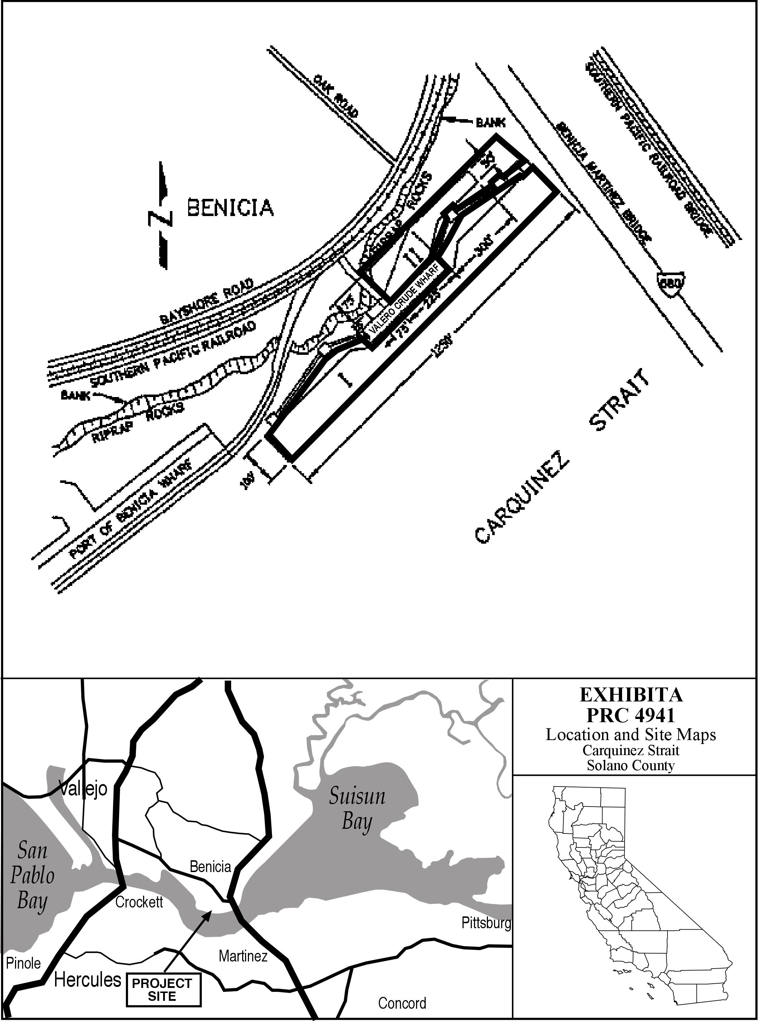

This exhibit is solely for purposes of generally defining the lease premises, is based on unverified information provided by the Lessee or other parties, and is not intended to be, nor shall it be construed as a waiver or limitation of any State interest in the subject or any other property.